

**本科实验报告**

|  |  |
| --- | --- |
| 课程名称： | 计算机体系结构 |
| 姓 名： | 周炜 |
| 学 院： | 计算机科学与技术学院 |
| 系： | 计算机科学与技术系 |
| 专 业： | 计算机科学与技术 |
| 学 号： | 3210103790 |
| 指导教师： | 卜凯 |

2023年 11 月 1 日

Lab 2: Pipelined CPU supporting

exception & interrupt

周炜 3210103790

1. **Purpose**

* Understand the principle of CPU exception & interrupt and its processing procedure.
* Master the design methods of pipelined CPU supporting exception & interrupt.
* Master methods of program verification of Pipelined CPU supporting exception & interrupt.

1. **Task**

* **Design** of Pipelined CPU supporting exception & interrupt.

Design **Exception Unit**

Design **datapath**

Design **Co-processor & Controller**

* **Verify** the Pipelined CPU with program and observe the execution of program.

1. **Experimental process and data recording**

**3.1 Experimental principle**

**Pipelined CPU supporting exception & interrupt**



For interrupt exceptions, our entire process should first detect the interrupt exception and then handle it. The detection process of interrupt exceptions is distributed in various stages of the pipeline. The experimental code has been given and is not the focus of this experiment.

The **focus of this experiment is on the interrupt and exception processing process**, which is the new exception unit part above.

In this experiment, exceptions were not actually handled **until the write back stage**, because at least no new exceptions will be generated after the write back stage. But in fact, there are still some small problems in handling exceptions in the WB stage. For example, the write operation of RAM is completed in the MEM stage, but this issue is not considered in the code provided for our experiment. You can ignore it during the experiment.

* When the writeback instruction reports an exception, it **clears all pipeline** level caches and sets the PC to the exception entry address.

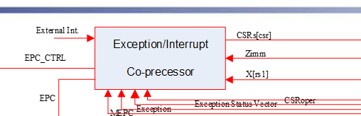

This module has two main functions:

1. When an interrupt exception occurs, the corresponding instruction will pass the relevant information to this module when it runs to the WB stage. This module will control the entry into the interrupt exception handler, and then control the exit after completion.

2. For the csr instruction, this module is used to control the corresponding register during the memory access phase of the csr instruction execution.

The csr and mret parts are done in the memory stage

Interrupt exception handling is done in the Write back stage

The main tasks of the **Exception Unit** module are.

1. Firstly, when an exception is entered, it is responsible for reading and writing registers such as mstatus.
2. Then, in the exception service program, it is responsible for executing the csr instruction to read and write the corresponding csr registers.
3. Finally, when exiting the exception, it is responsible for restoring mstatus and other registers.

**Exception**

an unusual condition occurring at run time associated with an instruction in the current RISC-V hart

**Interrupt**

an external asynchronous event that may cause a RISC-V hart to experience an unexpected transfer of control

**Precise Exceptions**

* All instructions before the faulting instruction complete.
* Instructions following the faulting instruction, including the faulting instruction, do not change the state of the machine.

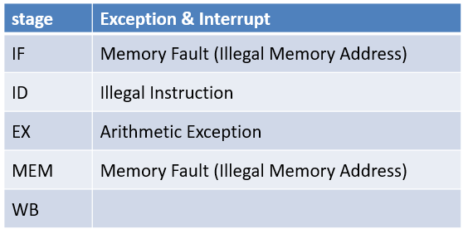

**Trap Resolve**

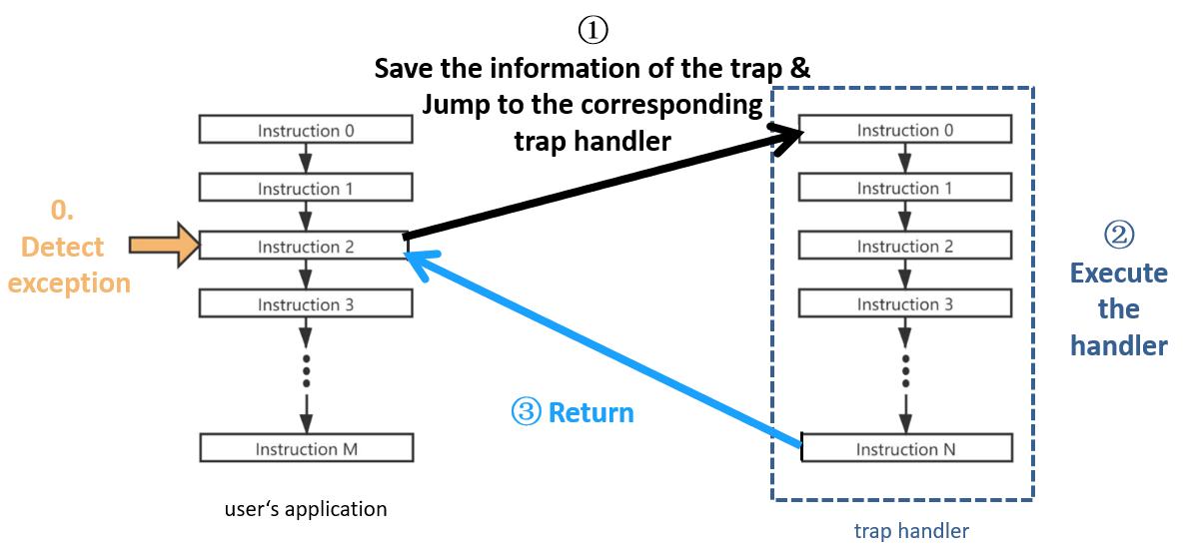

When we run along the program to an exception,

1. We save the interrupt exception information and then jump to the corresponding exception handler

2. Execute this handler

3. After completion, the last step jumps back to the original program to continue execution.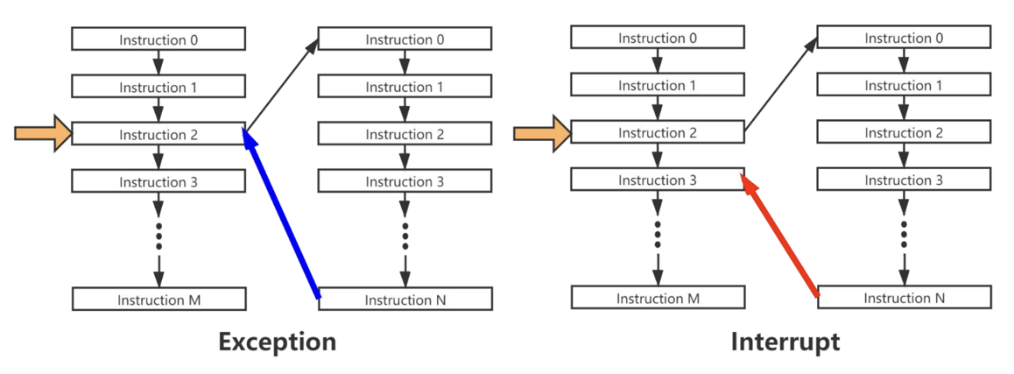

There is a difference in the handling of interrupts and exceptions.

For exceptions, jumping back to the original program will re-execute the instruction where the exception occurred.

But for interrupts, it returns to the execution of the next instruction after the instruction when the interrupt occurred.

**Control Status Registers (CSR)**

The format of the CSR address is shown in the figure on the left. Among the 12-bit CSR addresses, the highest two bits indicate the read and write permissions, and the next two bits indicate which privilege mode can use the CSR.

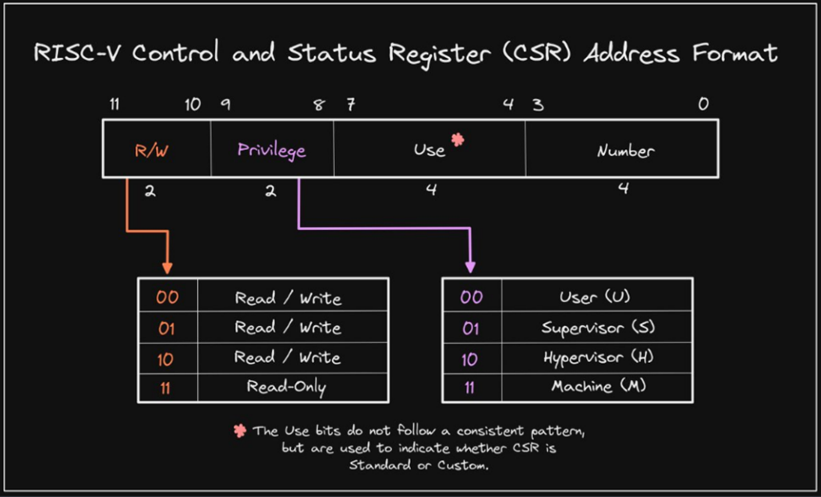

Several important CSR registers in machine mode (M):

|  |  |  |  |
| --- | --- | --- | --- |
| Number | Abbr | Name | Description |
| 0x300 | mstatus | Machine Status Register | 处理器状态，mstatus的MIE域和MPIE域用于反映全局中断使能 |
| 0x304 | mie | Machine Interrupt Enable Registers | 用于控制不同类型中断的局部中断使能 |
| 0x305 | mtvec | Machine Trap-Vector Base-Address Register | 定义进入异常的程序PC地址 |
| 0x341 | mepc | Machine Exception Program Counter | 用于保存异常的返回地址 |
| 0x342 | mcause | Machine Cause Register | 反映进入异常的原因 |
| 0x343 | mtval | Machine Trap Value Register | 反映进入异常的信息 |
| 0x344 | mip | Machine Interrupt Pending Registers | 反映不同类型中断的等待状态 |

**mstatus**

mstatus.**xIE**: Interrupt Enable in x mode 1 means open

mstatus.**xPIE**: Previous Interrupt Enable in x mode

mstatus.**xPP**: Previous Priviledge mode up to x mode

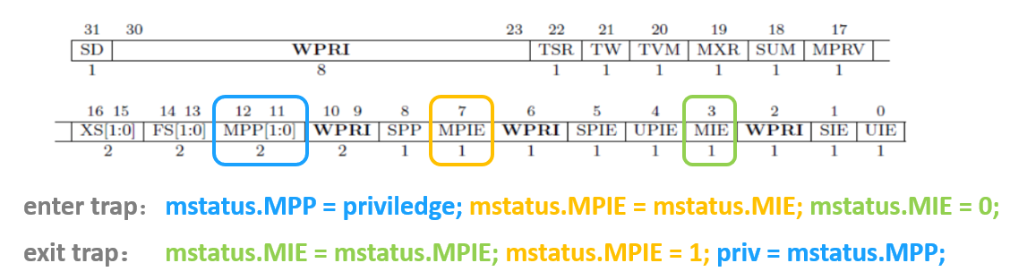

**mcause**

The highest bit of Mcause indicates whether this is an interrupt. A value of 1 indicates an interrupt, and a value of 0 indicates an exception occurred.

Our experiment **only focuses on the identified ones**

First is an interrupt

Then there is the exception

Illegal instruction

Load/Store address out of range

and ECALL

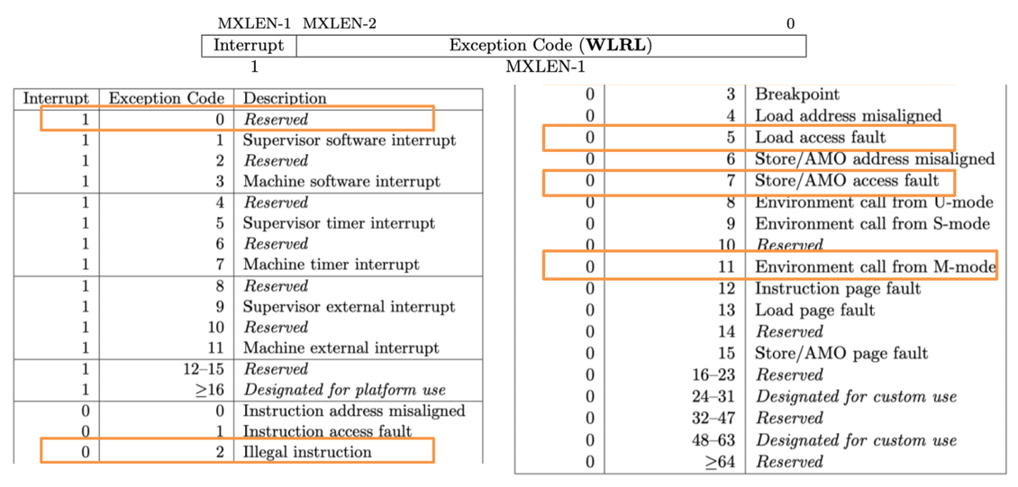

**mtvec**

we use the direct mode in the exp,

After entering the interrupt exception, you need to jump into the interrupt exception handler, and the target address of the jump will be stored in the mtvec register in advance.

Direct mode (direct), all types of interrupt exceptions will jump directly to the stored base address. That is, directly assign PC to base



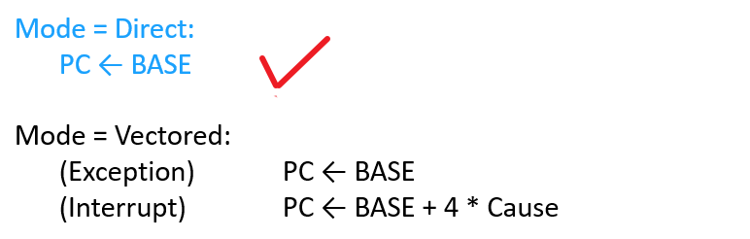

**mepc**



**CSR Instructions**

Format as follow:

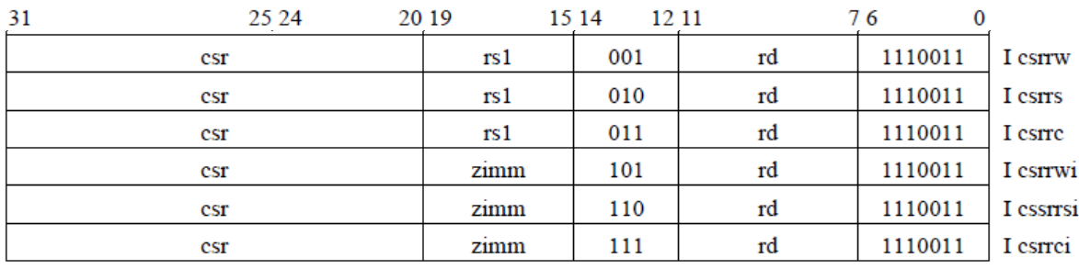

|  |  |  |  |
| --- | --- | --- | --- |
| inst. |  | |  |
| csrrw rd, csr, rs1 | | t←CSRs[csr], CSRs[csr]←x[rs1], x[rd] ← t | 读取一个 CSRs[csr] 的值到rd，然后把rs1写入该 CSR |
| csrrs rd, csr, rs1 | | t←CSRs[csr], CSRs[csr]←t|x[rs1], x[rd] ← t | 读取一个 CSR 的值到rd，然后把该 CSR 中rs1指定的 bit 置 1 |
| csrrc rd, csr, rs1 | | t←CSRs[csr], CSRs[csr] ← t&~x[rs1], x[rd] ← t | 读取一个 CSR 的值到rd，然后把该 CSR 中rs1指定的 bit 置 0 |
| csrrwi rd, csr, zimm[4:0] | | x[rd]←CSRs[csr], CSRs[csr] ← zimm |  |
| csrrsi rd, csr, zimm[4:0] | | x[rd]←CSRs[csr], CSRs[csr] ← t|zimm |  |
| csrrci rd, csr, zimm[4:0] | | x[rd]←CSRs[csr], CSRs[csr] ← t&~zimm |  |

**Machine-Mode Privileged Instructions**

The ECALL directive is used to make requests to the execution environment. Executing the ECALL directive has different effects at different privilege levels: in User Mode it raises the environment-call-from-U-mode exception, in Supervisor Mode it raises the environment-call-from-S mode in Supervisor Mode, and environment-call-from-S-mode in Machine.

In Supervisor Mode, the environment-call-from-S-mode exception is thrown, and in Machine Mode, the environment-call-from-M-mode exception is thrown.

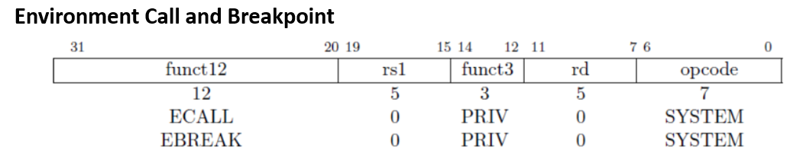

In our experiments, the exception handler returns with the mret instruction (an M-mode-specific instruction), which sets the PC to mepc, restores the previous interrupt enable setting by copying the MPIE field of mstatus to MIE, and sets the privilege mode to the value in the MPP field of mstatus.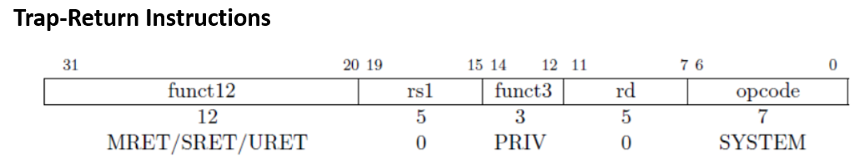

**Trap Handling Process – Enter Trap**

* Start from the PC address defined by the **CSR mtvec. And** Update the CSR registers: **mcause, mepc, and mstatus**

1. mstatus (mstatus[7]=mstatus[3], mstatus[3]= 0)
2. mepc (interrupt: Next PC, exception: Cur PC)
3. mcause (interrupt? ecall ? illegal inst? load fault? store fault?)

* Interrupt exception handler

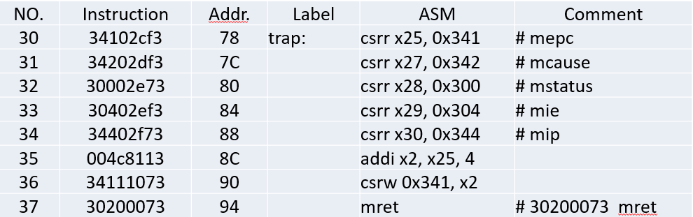

* Exit

1. Stop the execution of the current program
2. Start from the PC address defined by the CSR mepc.
3. Update the CSR mstatus. mstatus (mstatus[3] = mstatus[7], mstatus[7] = 1)

**3.2 Main Work**

Complete the ExceptionUnit.v: (already accessed in the top-level module RV32core.v)

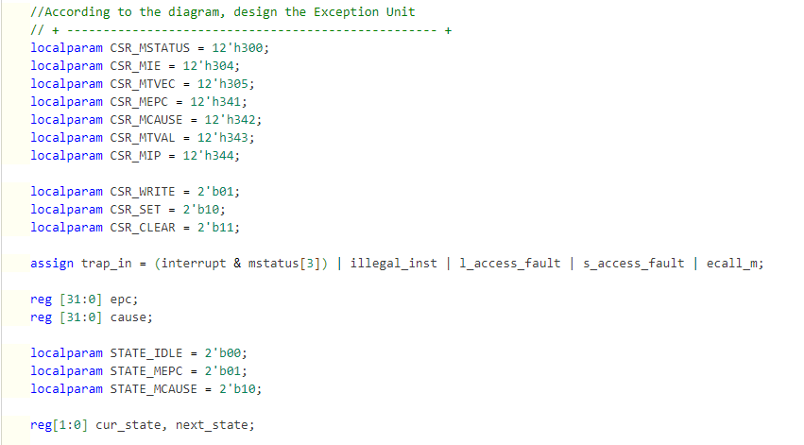

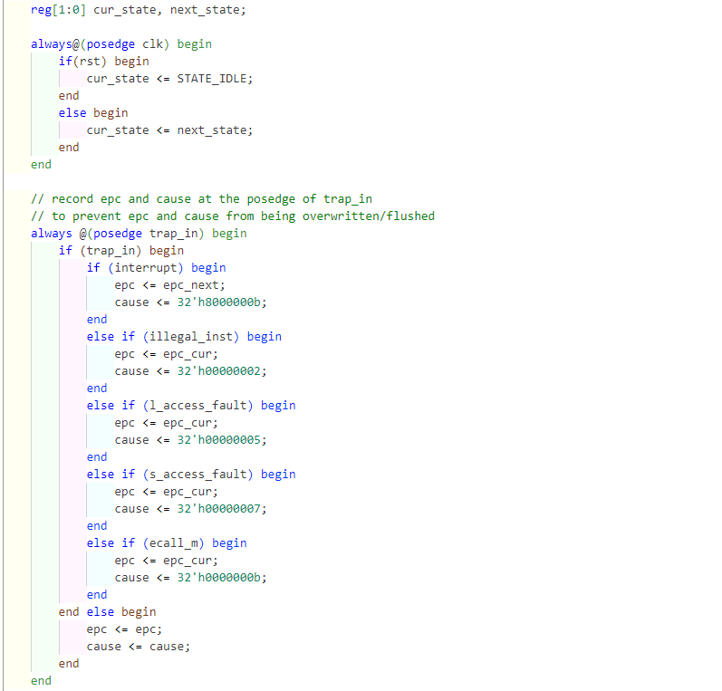

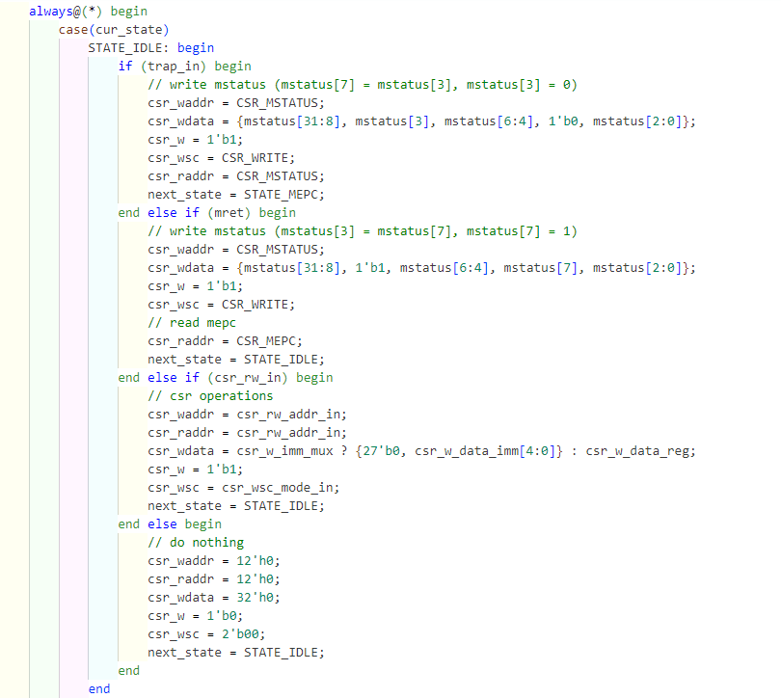

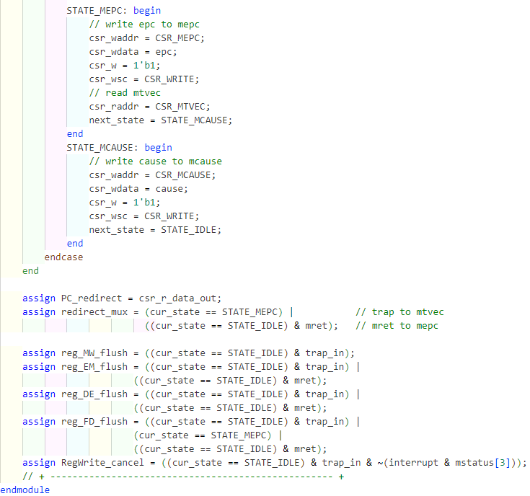

To complete privileged instructions in Code2Inst.v, first uncomment the annotated code, complete the legal instructions of each instruction, and then add the CSR instruction at the end：

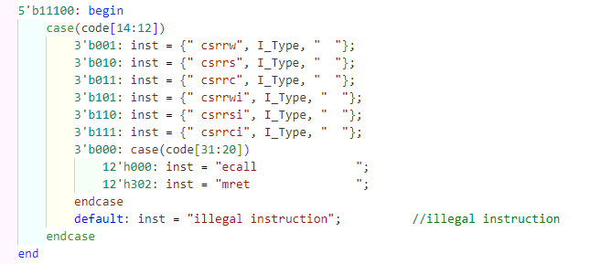

1. **Result and Analysis**

**4.1 Simulation results**

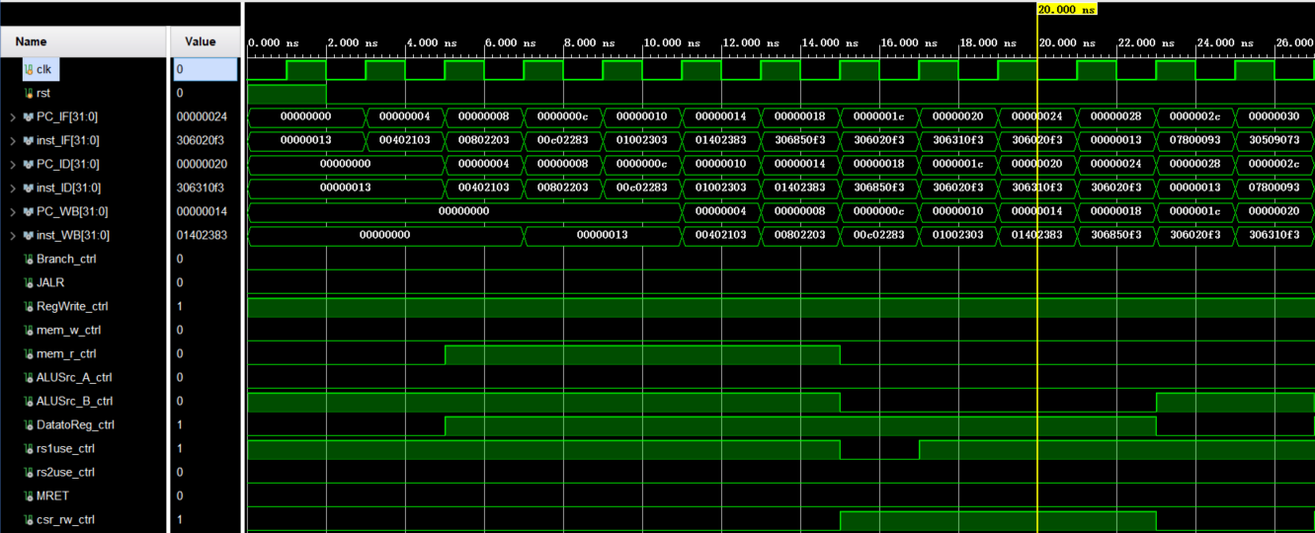

The location circled by this red box indicates that an ecall instruction was executed to the write back stage at this point, and then two cycles later, we observe the exception handler entering the pipeline

The reason for the one-cycle gap here is that our state machine redirects the PC only on the second cycle

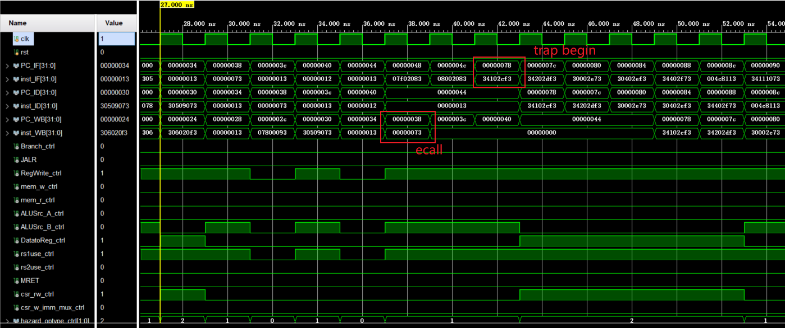

Then there's this part where the red box shows the mret instruction to the memory stage, and then in the next cycle we can observe that the PC jumps back to the next instruction of ecall

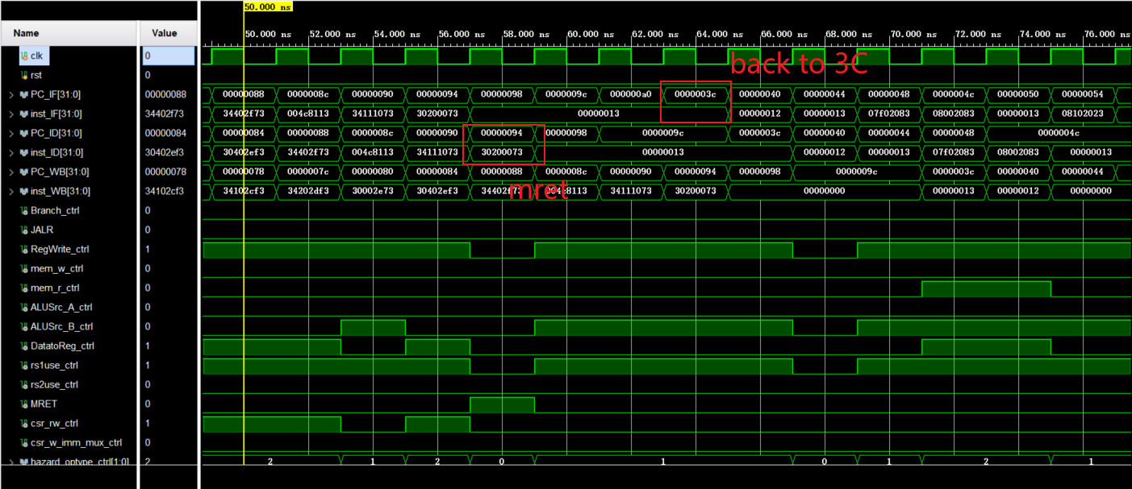 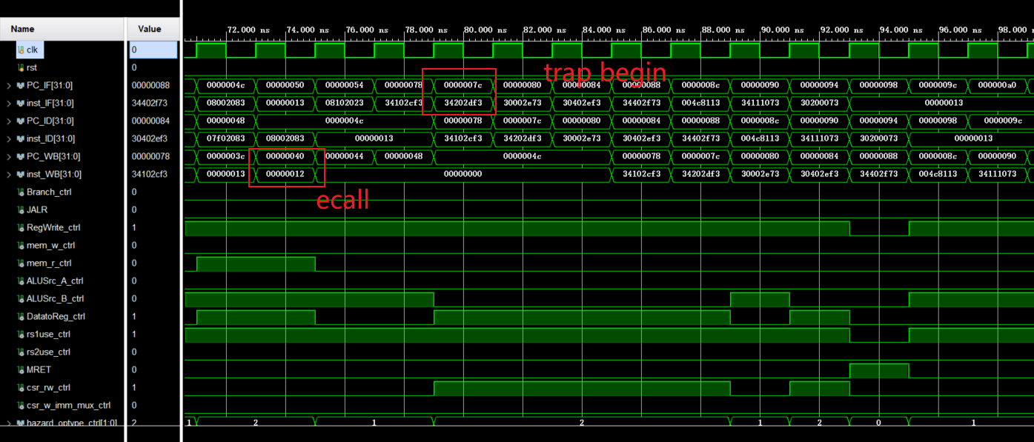

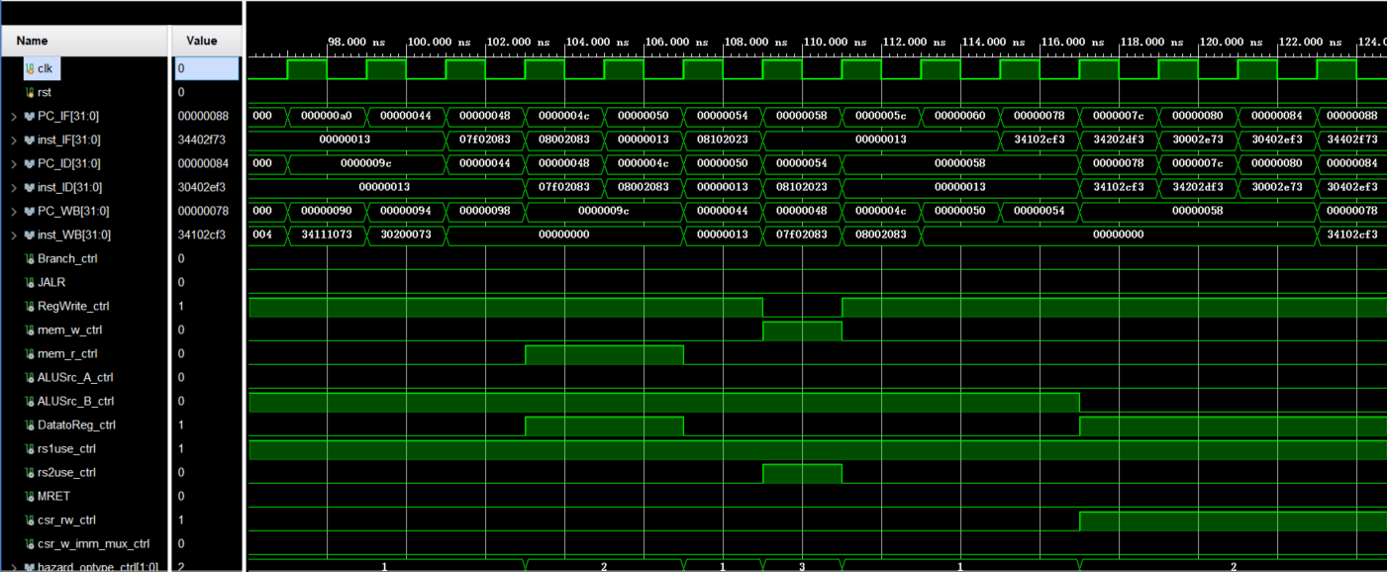

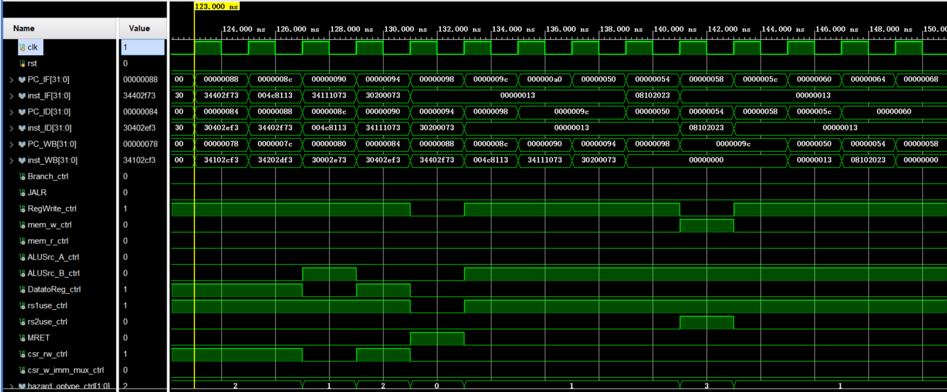

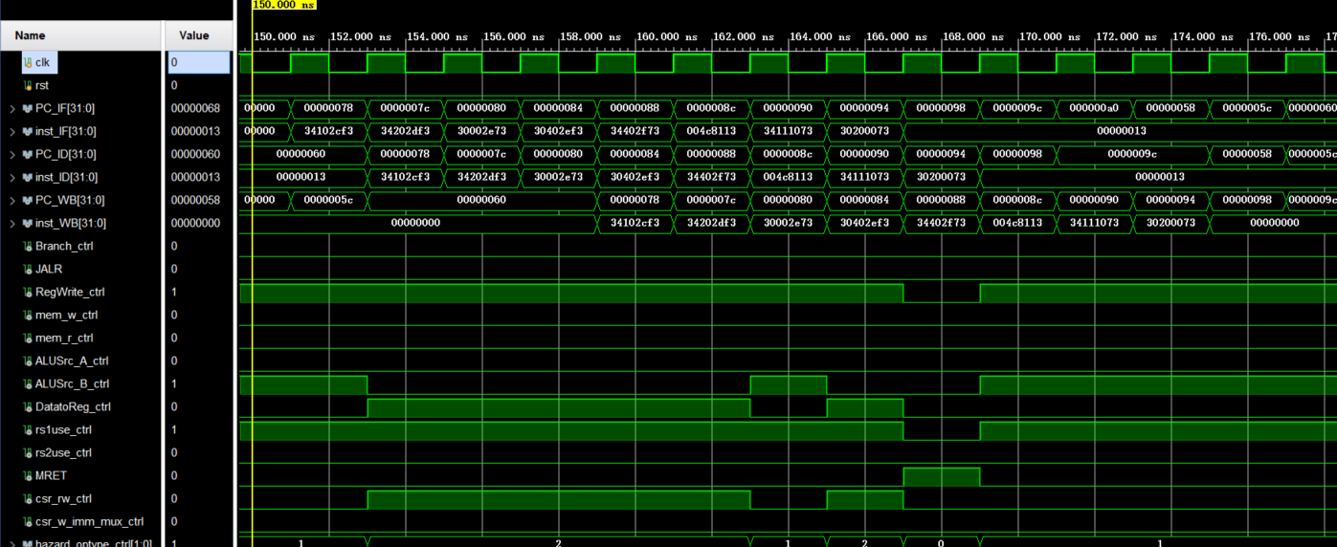

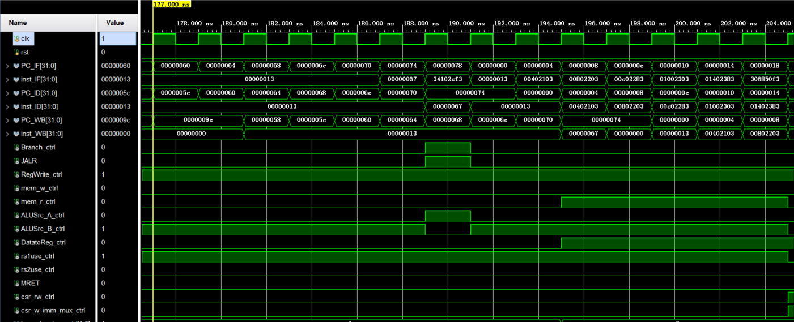

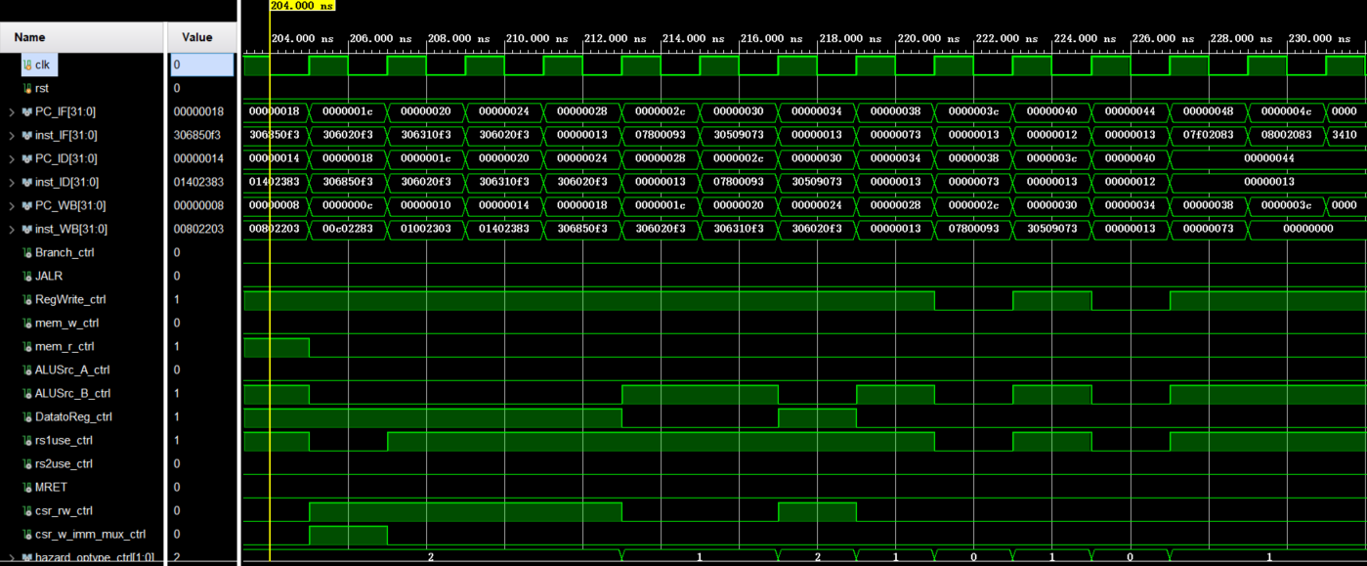

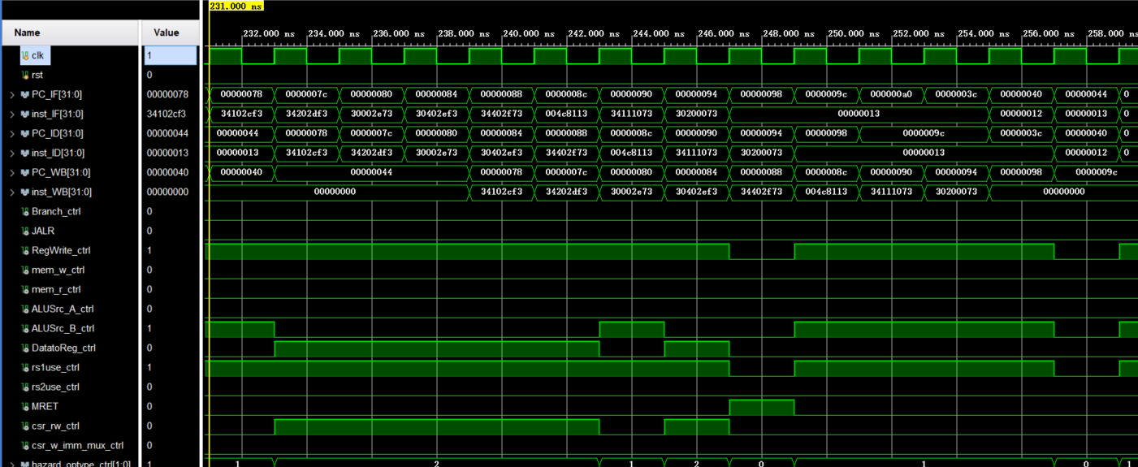

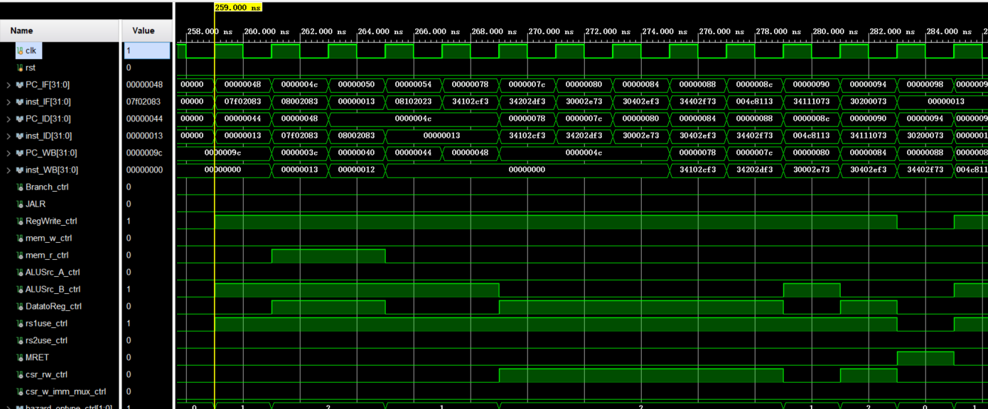

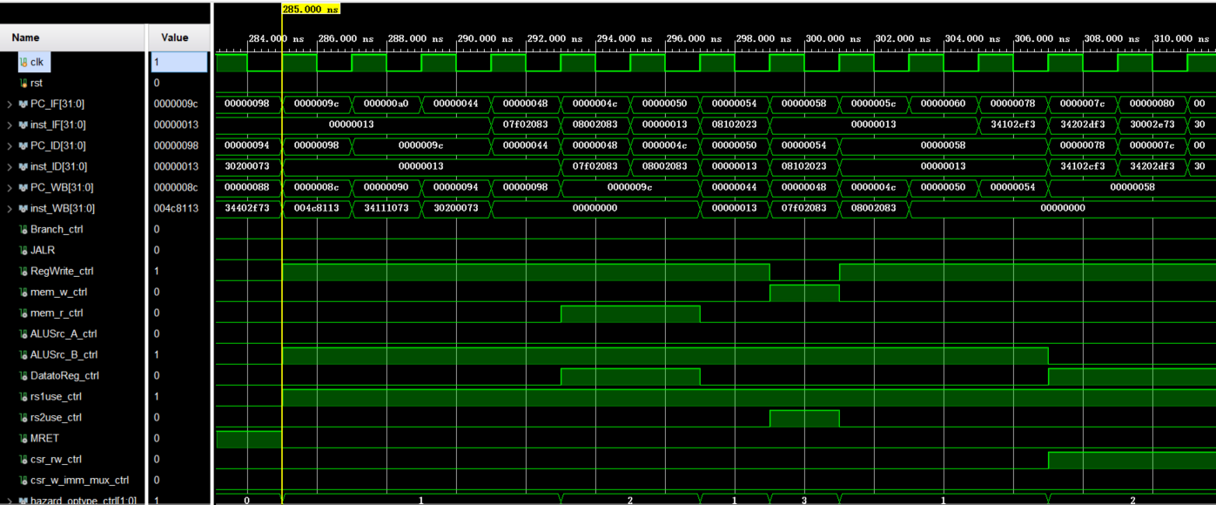

……

**4.2 Physical verification**

first instruction

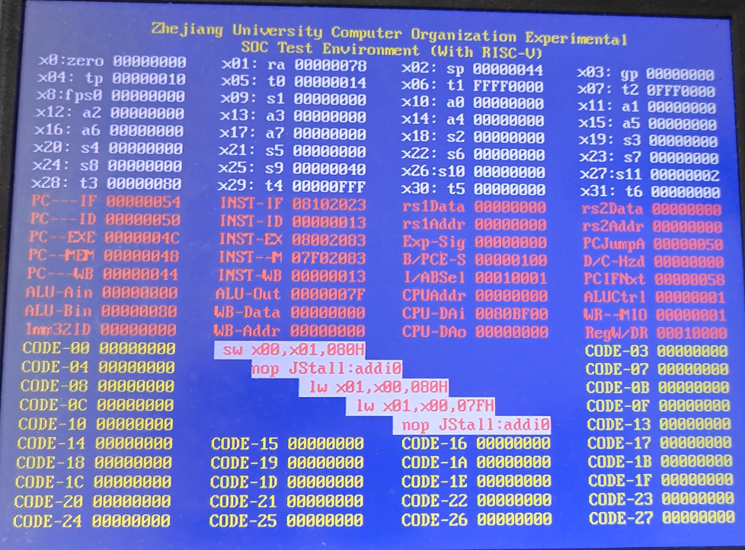

And next

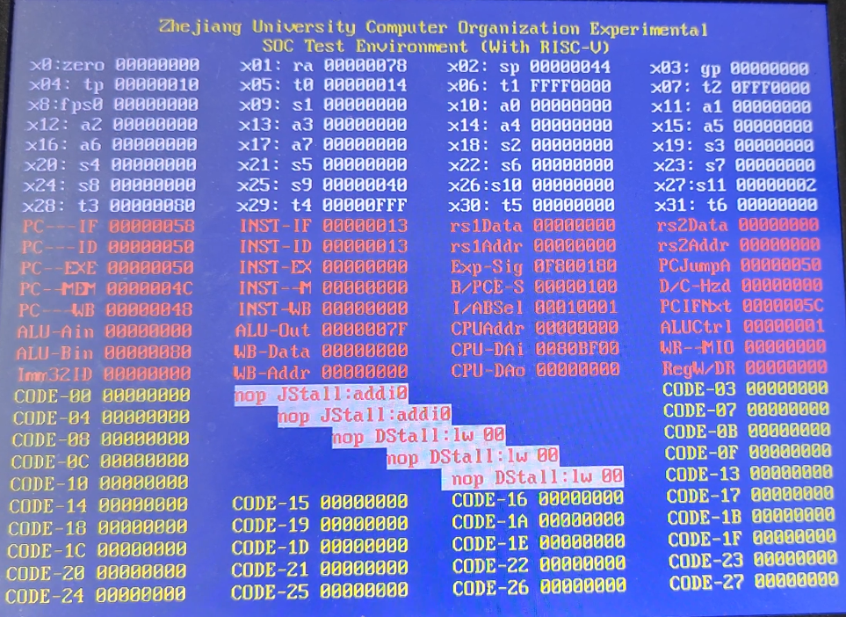

Press switch 12, the test is interrupted

Enter interrupt handler

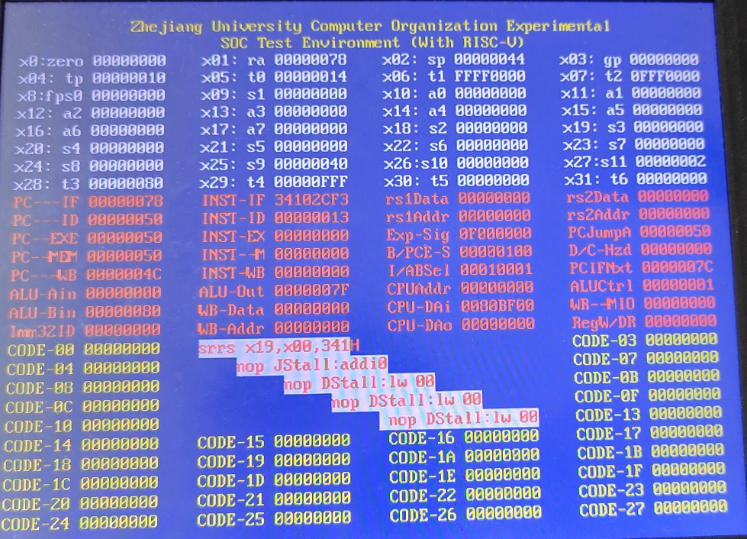

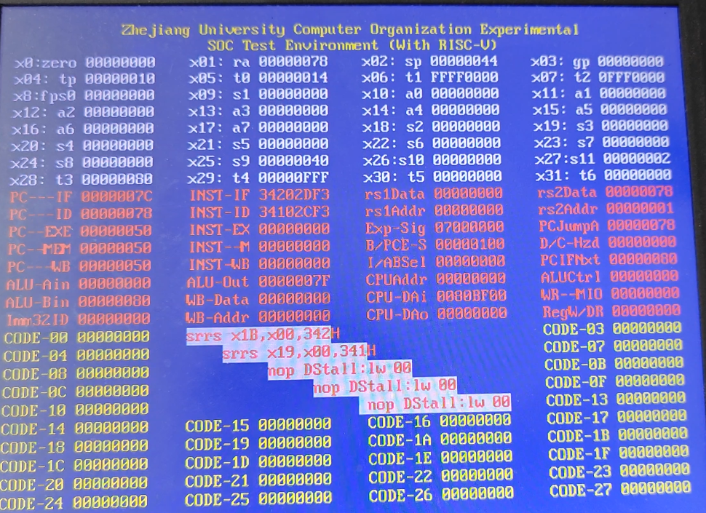

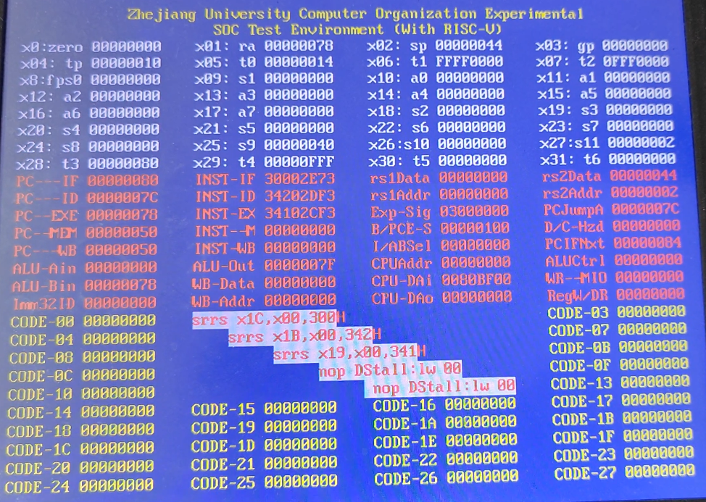

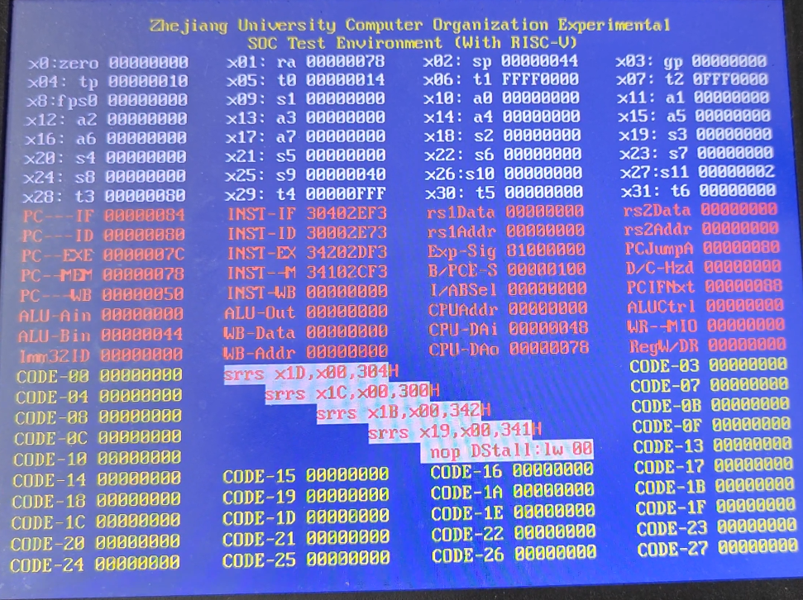

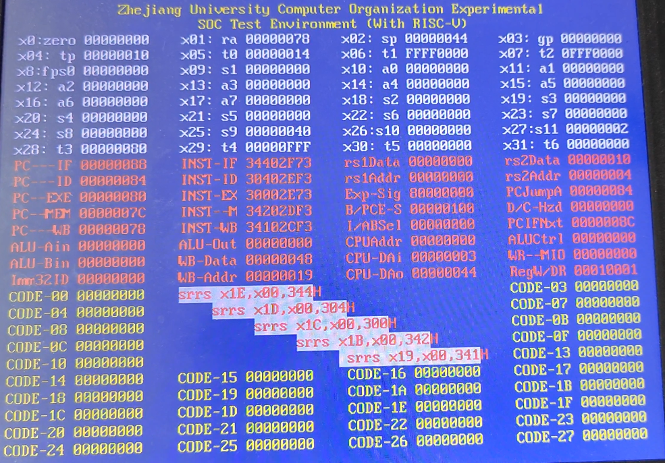

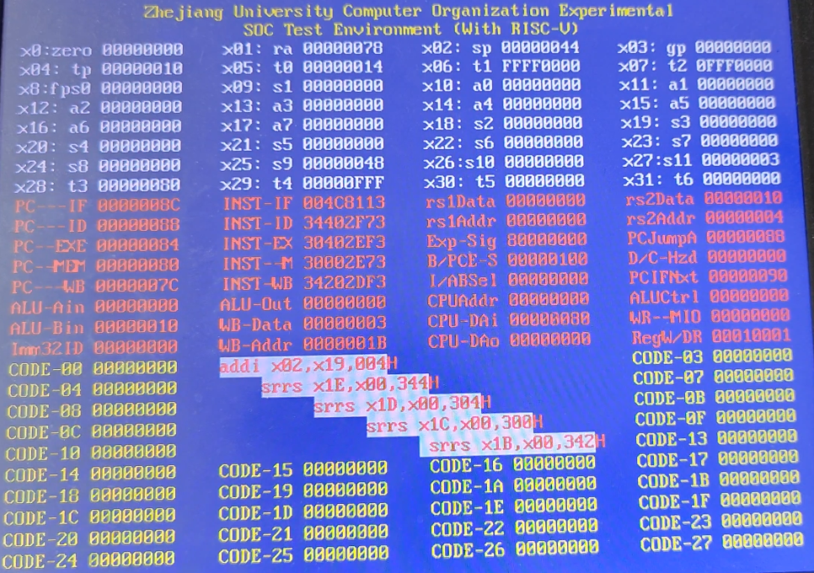

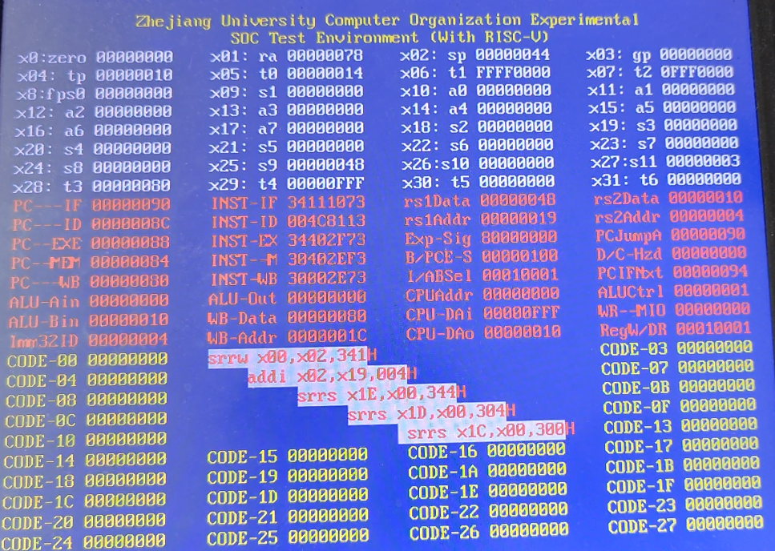

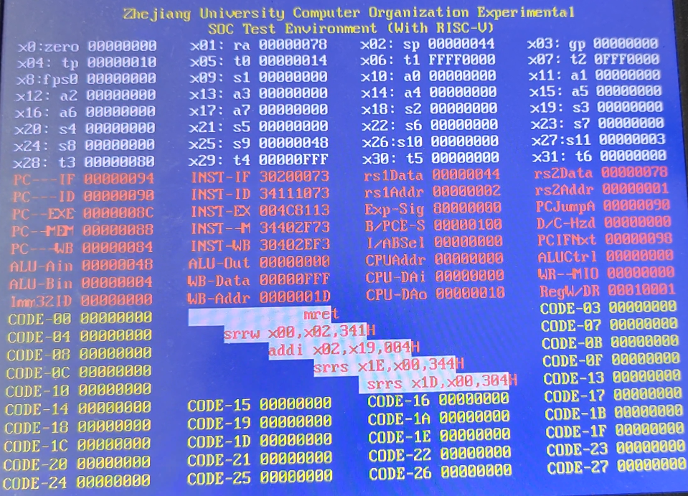

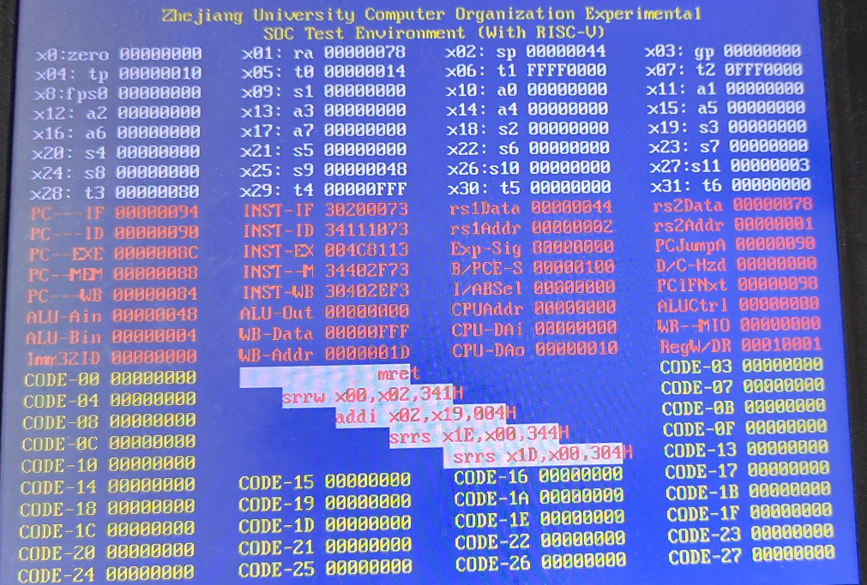

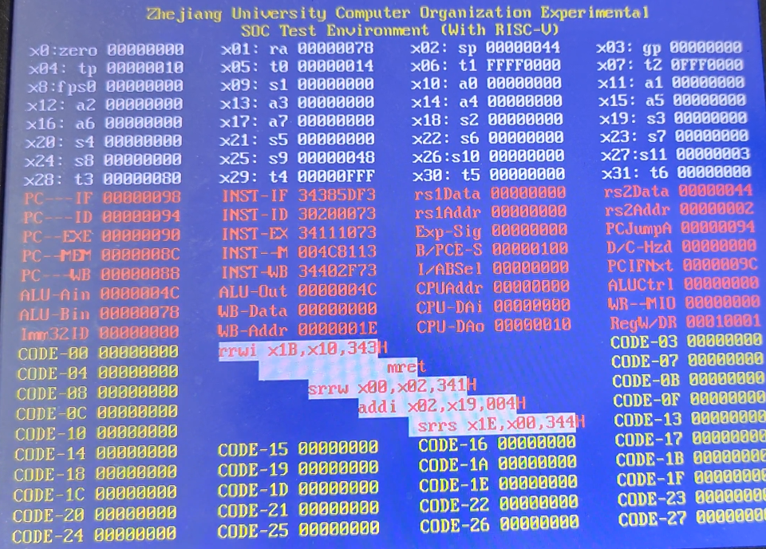

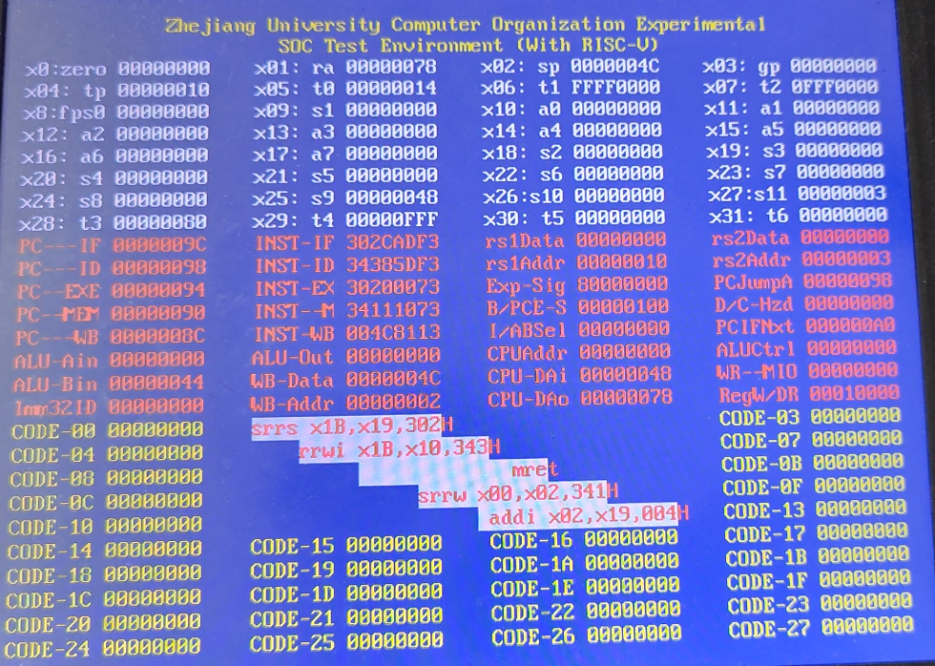

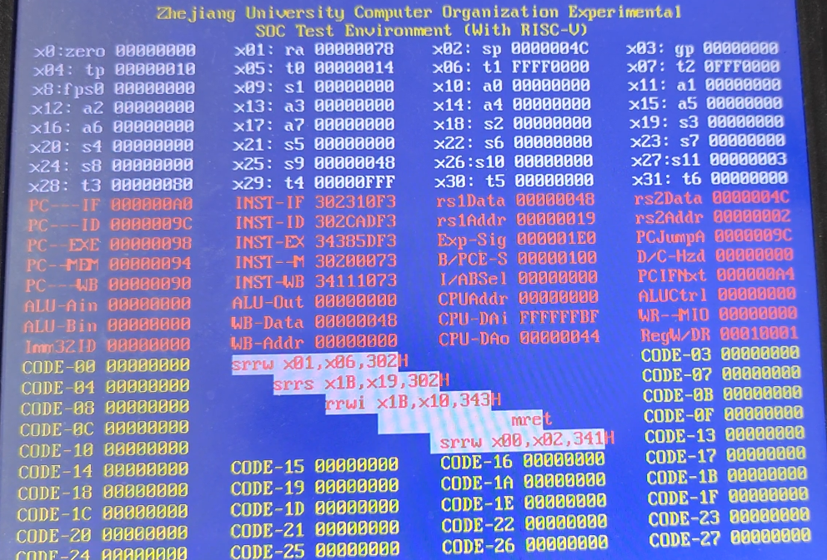

After the interrupt processing is completed, return to the original PC

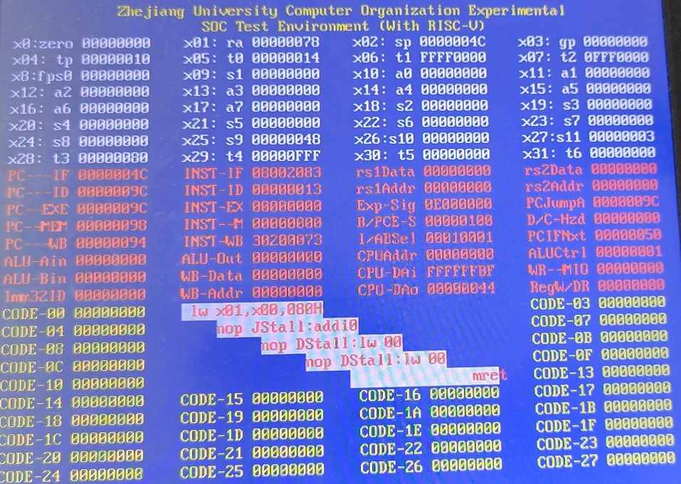

1. **Discussion and thoughts**

In this experiment, I gained practical experience in designing a pipelined CPU for RISC-V RV32I instructions with a focus on handling exceptions and interrupts , tackling with the module, responsible for CSR management, interrupt handling, and executing CSR instructions during memory access.

This experiment provided hands-on knowledge in designing CPUs capable of efficiently managing exceptions and interrupts, emphasizing CSR registers and trap handling. This knowledge is essential for understanding CPU robustness in handling unexpected events.